הרב אהרן מרדכי בן הרב ברוך ליבערמאן זצ"ל הי"ד
אב"ד קה"י פעלעדיהאז
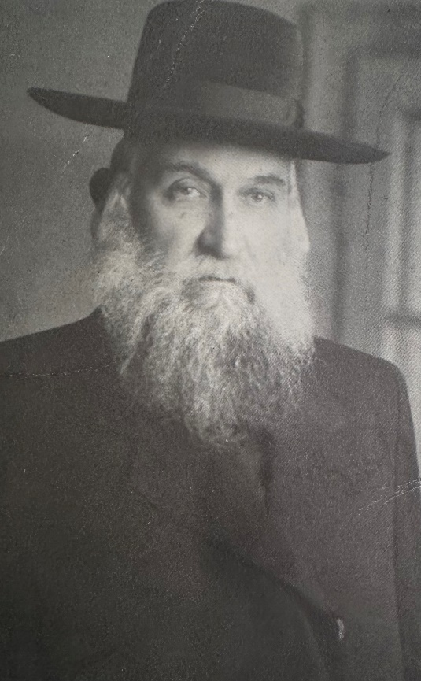
Among the uniquely gifted rabonim of prewar Czechoslovakia and Hungary was Reb Aharon Mordechai Lieberman, an individual whose greatness in Torah was matched by his broad vision and deep sense of communal responsibility. He was known for his boundless energy in advancing the needs of the tzibur, and wherever he went, he commanded admiration and respect—not only for his learning, but also for his noble character and ability to lead with both firmness and sensitivity. In addition to his gadlus in Torah, he possessed a wide general education, fluency in multiple languages, and a rare ability to relate to people of diverse backgrounds.
Reb Aharon Mordechai was born in 5647 (1887) in the city of Balassagyarmat, into a family steeped in rabbinic lineage and Torah scholarship. His father, Reb Boruch Lieberman, was a revered talmid chacham who served as Av Beis Din of the community. Reb Boruch had been the assistant rabbi to the renowned posek, Reb Aharon Dovid Deutsch, baal mechaber Goren Dovid, and one of the talmidei muvhak of the Chasam Sofer. From his paternal line, Reb Aharon Mordechai traced his ancestry to Reb Meir Avraham Klein, the Av Beis Din of Tsheba, who was a talmid of the Machatzis Hashekel and the baal mechaber of sefer Pri Tzaddik al haTorah. Reb Boruch’s father was a rav in Shenya, a position held by the Lieberman family for more than one hundred years, establishing a legacy of rabanus that spanned generations.
It was said by the famed Reb Shmuel Rosenberg, the Beer Shmuel, that Reb Boruch was a man who truly sacrificed for Yiddishkeit. When he saw that the city where he was then residing no longer upheld mitzvos properly—and that public chilul Shabbos had become commonplace—he made a bold and painful decision: rather than raise his family in an environment drifting from Torah values, he uprooted his family and resettled in Balassagyarmat, where he could build his home upon a stronger spiritual foundation. It was in that nurturing environment, steeped in Torah and mesorah, that young Aharon Mordechai was raised.
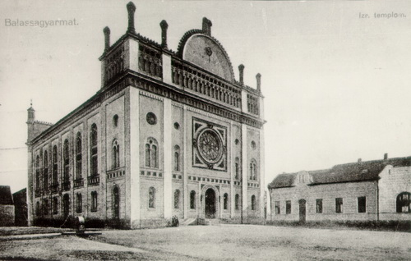
The Balassagyarmat shul, one of the largest orthodox shuls in Central Europe. The building was nearly five stories high, with a capacity to fit 4,000 people. During WWII the shul was used for ammunition storage by the nazis ym”sh, and on December 8, 1944 before retreating from the city, they blew up the shul r”l.
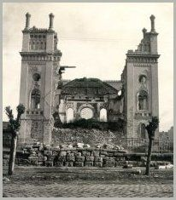
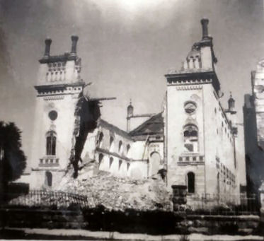
The ruins of the shul r”l

Reb Aharon Mordechai would go on to become one of the central figures in Orthodox Jewish leadership in Subcarpathian Ruthenia. He served as President of the Lishka, the Orthodox Bureau headquartered in Ungvár, the region’s capital. In that role, he stood at the very heart of rabbinic life and halachic policy, representing communities across the region. At the same time, he was deeply involved in strengthening Jewish education, upholding kashrus, and organizing communal institutions. His life’s mission was to raise the stature of Torah and its bearers, and to fortify Yiddishkeit in the face of the many challenges that confronted Hungarian Jewry in the interwar period.
Already in his youth, Reb Aharon Mordechai Lieberman displayed exceptional and uncommon talents. It was evident to all that from within the city of Balassagyarmat was rising a towering young cedar—a brilliant prodigy whose heart was drawn to ascend the heights of Torah. From an early age, he demonstrated remarkable clarity of mind and spiritual sensitivity. Firm in his resolve he set out to learn at the yeshivah of the gaon and kadosh, Reb Shmuel Rosenberg, Av Beis Din of Unsdorf and baal mechaber of Be’er Shmuel. The Unsdorf yeshiva was among the most esteemed Torah centers of that era, attracting the most serious and capable students of Hungary and the surrounding regions.
In the home of the Be’er Shmuel, young Aharon Mordechai was welcomed with extraordinary warmth and affection. His rebbi saw in him a pure and noble soul and invited him to live in his own home—a privilege rarely granted to any talmid. This closeness was further deepened by a personal connection: the Be’er Shmuel’s rebbetzin, like Reb Aharon Mordechai, was a descendant of the Pri Tzaddik, , linking them as einiklach of the same spiritual legacy.
Under the guidance of the Beer Shmuel, Reb Aharon Mordechai’s character was molded and elevated. His inner strength was forged in the spiritual fires of Unsdorf, and the enduring imprint of his rebbi’s influence remained visible upon him throughout his life. From Reb Shmuel, he absorbed not only vast Torah knowledge, but also the deep values of yiras Shamayim, humility, and uncompromising commitment to halachah³.
At the age of eighteen, Reb Aharon Mordechai entered into marriage with Rebbetzin Frumit, the daughter of Rabbi Yaakov Beilush, Av Beis Din of Yanashi (Kántorjánosi) in the Szabolcs region of Hungary. Reb Yaakov was a prominent Torah figure, talmid as well as a hoiz bochur of Reb Yehudah Assad and the son-in-law of the tzaddik Reb Naftali Hertzke of Ratzfert, renowned throughout Hungary and beyond as a poel yeshuos. The shidduch was arranged by Reb Hershel Liska, baal mechaber Ach Pri Tevuah, who was known to have played a central role when Reb Herzkele of Ratzfert came to Liska seeking a shidduch for his daughter, Bina Gittel.
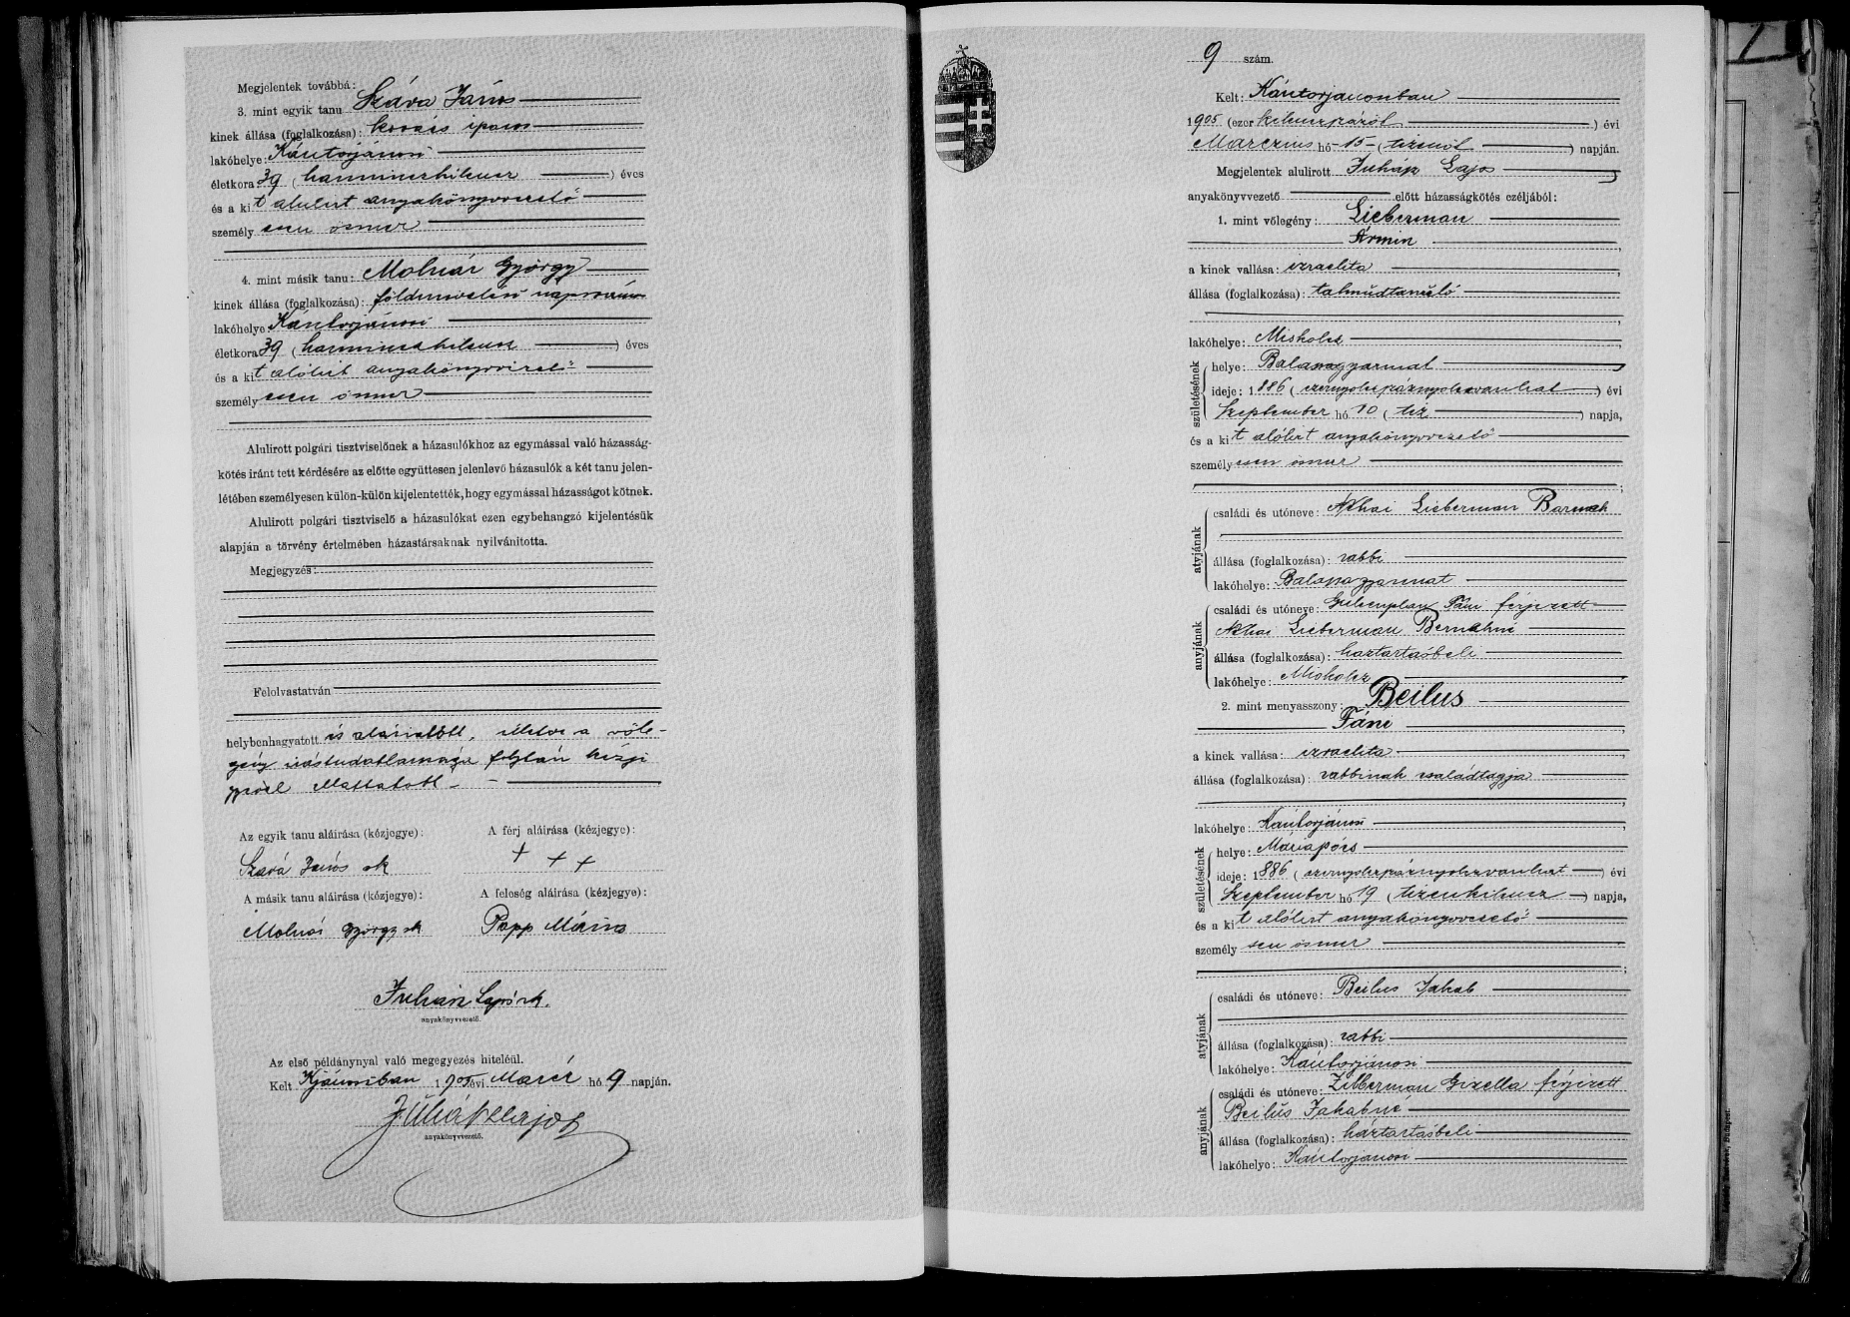
Marriage Certificate of Ármin Lieberman (son of Barnak Lieberman and Fani Gulienplan) and Fáni Beilus, married on March 15, 1905 in Kántorjánosi, Szatmár, Hungary.
Following his marriage, Reb Aharon Mordechai lived for several years in the home of his esteemed father-in-law. There, he devoted himself with singular focus to limud haTorah, learning with diligence and intensity. His ascent in all areas of yedi’as haTorah was both steady and remarkable. Reb Yaakov Beilush, known for his tzidkus, kedushah, and above all, his unmatched diligence in Torah study, poured his own spirit into his son-in-law. During this formative period, Reb Aharon Mordechai completed his training in hora’ah and became thoroughly proficient in practical halachah.
Having acquired profound knowledge and demonstrable skill in halachic decision-making, Reb Aharon Mordechai was granted semichah by his rebbi, the Be’er Shmuel, and also received semichah from the eminent Rav Eliezer Dovid Greenwald, Av Beis Din of Satmar and baal mechaber of Keren LeDovid, as well as from other leading Torah authorities of the time.

Rabbanus
When Reb Aharon Mordechai Lieberman arrived in Bilke around 1915, in the midst of World War I, he brought with him a rare combination of Torah brilliance, worldly knowledge, and forceful leadership. A talmid of the Be’er Shmuel of Unsdorf and son-in-law of Rabbi Yaakov Beilush, Reb Aharon Mordechai was already recognized as a rising figure in Carpathian Hungary. Almost immediately upon settling in Bilke, he founded a large yeshiva, which attracted bochurim from across the surrounding towns. His older sons assisted him in the yeshiva, and its graduates would go on to study in the elite yeshivos of Slovakia—Pressburg, Galánta, Nitra, Serdehel, and Unsdorf. He served not only as rav and rosh yeshiva, but also as the town’s mohel. One resident, Dovid Stern, later recalled that he was Rabbi Lieberman's first bris in Bilke.
On a Mission for the Sake of the Community
During this period, RebAharon Mordechai Lieberman stood out as a tireless advocate for the needs of the broader community, becoming a trusted address for all who required help. His vibrant energy, deep compassion, and willingness to sacrifice for others were vividly demonstrated in one remarkable episode that left a lasting impression on all who heard it.
As Pesach approached, a grave crisis threatened the Jewish communities in the region: there was no wheat available for baking matzos. The war was raging, basic food supplies were scarce, and even the black market had run dry. Roads were impassable, transportation had collapsed, and grain merchants were unable to bring in any supply. The situation was dire—without intervention, the entire region risked facing Yom Tov without matzah.
With no solution in sight, the leaders of the surrounding towns and villages turned to Reb Aharon Mordechai Lieberman of Bilke. They recognized in him a rare figure—respected for his Torah knowledge, admired for his character, and trusted for his courage and determination. They pleaded with him to act as their representative and travel to Budapest to appeal directly to the authorities for a supply of wheat for the community’s matzah needs.
It was an demanding and uncertain mission. The journey was long and difficult, and navigating government bureaucracy in wartime was no less challenging, but Reb Aharon Mordechai accepted the task. Upon arriving in Budapest, he immediately began lobbying officials, visiting one office after another, speaking with anyone who might be able to help. For weeks, he persisted—working through red tape, mobilizing support, and pressing the urgency of the matter to anyone who would listen.
Ultimately, his efforts bore fruit. The Hungarian authorities, in coordination with the Orthodox Bureau (Lishka) in Budapest, responded to his appeal and approved the release of several train cars of wheat and flour designated specifically for the region’s Jewish communities. The supplies arrived in time, and thanks to his relentless efforts, the Jews of the region had wheat to bake their matzos for Pesach.
The Jews of Carpatho-Rus: Between Empires
In the aftermath of World War I, the Jews of Carpatho-Rus faced a new and harrowing reality. As soldiers slowly returned from the front, broken and weary, families began searching for ways to rebuild their lives—seeking sustenance, stability, and a return to normalcy. But the scars of war ran deep. For four long years, communities had been torn apart, families separated, and entire towns and villages disrupted. When the war ended, many discovered that life as they had known it no longer existed.
The economic structure had collapsed. People who had once lived comfortably—merchants, landowners, tradesmen—were now destitute. Many returned to find their homes in ruin and their livelihoods lost. Widows mourned husbands who had fallen in battle or gone missing in action. Grieving parents wept for sons who would never return. And most heartbreaking of all were the countless orphans, left with no one to protect them, no one to care for them.
Despair swept through the region, accompanied by hunger, poverty, and helplessness. It was a time of chaos and upheaval. What was needed was not just sympathy, but bold and immediate action—a coordinated rescue and relief effort that could bring both material assistance and emotional support to those who had been broken by war.
Reb Aharon Mordechai Lieberman of Bilke rose to meet that moment. He could not bear to stand by as his people suffered. The cries of the almanos, the desperation of the poor, and the silent pain of the yesomim stirred him to act. Without delay, he launched an ambitious and tireless campaign to bring help to the region. Reb Aharon Mordechai poured every ounce of energy into mobilizing resources and establishing an infrastructure of support for the afflicted.
Through his persistent advocacy and unshakable determination, Reb Aharon Mordechai succeeded in convincing the leadership of the Joint Distribution Committee (the Joint)—the American Jewish relief organization founded during the war—to expand its operations and include the devastated Jewish communities of Carpatho-Rus in its aid efforts. These were towns and villages that had long been overlooked, their cries unheard and unanswered.
One moment from that time remained etched in the hearts of all who witnessed it: the day an official automobile of the Joint Distribution Committee, bearing American insignia, arrived at Reb Aharon Mordechai’s home in Bilke. Such a sight was almost unimaginable in that era. A wave of emotion swept through the town. Thousands gathered, filled with anticipation and hope, waiting anxiously outside the rov’s home to see what might come of this historic visit—and whether true relief had finally arrived.
It was not long before the answer came. A public announcement was issued: all who required assistance were to prepare documentation and appear at a designated time and place to receive their portion of aid. Thanks to Reb Aharon Mordechai’s relentless efforts, a lifeline had been extended to a forgotten region, and the Jews of Carpatho-Rus would not be left to suffer alone.
The Unification of Orthodox Jewry in Carpatho-Rus
With the conclusion of World War I, the Carpatho-Rus region was separated from Hungary and annexed to the newly established state of Czechoslovakia. This event marked a dramatic shift in the lives of the region’s inhabitants. A new atmosphere of complete freedom and individual equality began to fill the air—a development that also influenced the local Jewish population.
During this period, the Jews gradually returned to a more stable and orderly way of life, slowly regaining their economic footing. It was also a fitting moment for spiritual renewal and communal organization, with the goal of restoring Jewish communal life to the strength and structure it had enjoyed in earlier years.
These were days of upheaval and shifting values within the Jewish world as well. Foreign winds of secularism began to sweep through Jewish communities. Secular Jewish parties emerged, spreading ideas of heresy that stood in stark contrast to the spirit of Torah and tradition. These ideologies caught hold among the youth like wildfire among dry straw.
Seizing upon the confusion of the time, these parties sought to win over followers from within the beit midrash and yeshivah circles. They laid traps for many young Torah scholars, luring them with the bait of joining various Zionist movements and parties—an initial step that often led, intentionally, to drawing them into the arms of secularism.
The secular activists especially targeted gifted and promising young men, sparing no effort to sever the finest yeshivah students from the pure wellspring of Torah learning—all with the goal of assimilating them into their own ranks. With fervor and ambition, they set their sights on gaining control over the leadership of the sacred Jewish communities in Carpathian Russia and sought to assert their influence over Jewish communal life.
This alarming situation demanded a strong and resolute response. It became imperative to form a powerful and united Orthodox front—one that could stand guard, actively resist the encroaching forces, and at the same time protect the legitimate rights of the communities to manage their affairs in the spirit of traditional Judaism, safeguarding them from every foreign influence lurking at the gates.
The question of organizing the Jewish communities and defining their official status had already been raised prior to World War I. However, the outbreak of the war had pushed the issue aside, rendering it temporarily irrelevant. With the war’s end and the establishment of the Czechoslovak Republic in 5678 (1918)—a state that proudly proclaimed civil liberty and equal rights for all citizens—the matter reemerged with even greater urgency.
The promise of equal rights for Jews carried profound implications and far-reaching consequences for the future character of Jewish communal life. It effectively gave a “green light” to those who had long been planning and scheming to seize control of the communities. Empowered by the new political climate, they saw an opportunity to advance their agenda and attempt to dominate the leadership of Jewish public life.
In response to these challenges, the Torah giants of the region rose to action. Leading rabbonim—including Rabbi Shlomo Sofer of Beregszász (son of the Ksav Sofer), Rabbi Yosef Tzvi Dushinsky of Khust (who later emigrated to Eretz Yisrael and succeeded Rabbi Yosef Chaim Sonnenfeld as Raavad of Yerushalayim), and Rabbi Avraham Yosef Grünwald of Ungvár—joined forces to establish the Lishkas HaYire’im, the Orthodox Bureau of Carpatho-Rus. Headquartered in Ungvár, and modeled after the central Orthodox Bureau in Pressburg, the institution became the spiritual and administrative hub for Orthodox Jewry throughout the region, issuing guidance and rulings on all pressing matters of the day.
Rabbi Aharon Mordechai Lieberman quickly emerged as one of its most prominent figures. His reputation extended far beyond Bilke, and he was appointed to a leadership position in the Bureau, eventually rising to serve as its president. In that role, he represented the Orthodox community in negotiations with the Czechoslovak government, staunchly defending religious autonomy and resisting secular encroachment. His eloquence and moral authority made him a sought-after speaker and a trusted mediator. In May 1926, the Deputy Governor personally summoned him to help resolve communal disputes in five towns, including Ilosva and Brod—a testament to the government’s recognition of his stature and integrity, even amid rising tensions within his own community.
Reb Aharon Mordechai also maintained a close friendship with Rabbi Yoel Teitelbaum zt”l. Reb Aharon Mordechai frequently had to travel to the city of Orshiva, where the judges and district officials of the regional government were located, as Bilke was included within the jurisdiction of the “Bereg” district. The judges greatly respected and gave significant weight to the opinions of the rabbonim, and therefore Reb Aharon Mordehai was often required to appear before the local authorities. On such occasions, Reb Aharon Mordechai would always take the opportunity to visit Reb Yoel, and the two would converse with warmth and affection.
Defending the Authority of Siget
In 1923, a pivotal territorial shift reshaped the communal allegiances of the Jewish communities in the Marmarosh region. The Treaty of Trianon had already redrawn the map of Central Europe following World War I, and by that year, Marmarosh was effectively split between Czechoslovakia and Romania. The city of Sighet, historically a central rabbinic authority, remained within Romania, while the nearby town of Ober-Apsha fell under the jurisdiction of the newly formed state of Czechoslovakia.
This geopolitical shift raised complex halachic and communal questions. A faction within Ober-Apsha began to claim that, since the town was no longer politically tied to Siget, it was no longer obligated to remain under the authority of the Sigeter Rebbe, the Atzei Chaim (Reb Chaim Tzvi Teitelbaum, son of the Kedushas Yom Tov and father of the Beirach Moshe). They argued that the rabbinic leadership of Siget no longer had jurisdiction over a kehillah situated in another country.

In an effort to resolve the dispute, both sides agreed to bring the matter before Rabbi Yosef Tzvi Dushinsky, the esteemed Rav of Chust and one of the most respected halachic authorities in Czechoslovakia. Rabbi Dushinsky ruled unequivocally in favor of the Atzei Chaim and maintained that the geographic border shift did not sever the religious and halachic ties between Ober-Apsha and Siget. However, the dissenting faction refused to accept the psak, deepening the division.
In response, a powerful public letter (michtav galui) was published in the periodical Beis Vaad Lachachomim, sharply condemning the rebellious faction and warning of the grave consequences of their defiance. The letter, signed by several of the leading rabbinic figures of the time—including the Av Beis Din of Ungvár, the AB"D of Szőlős (Selish), the AB"D of Volove, the AB"D of Torna, and Rabbi Aharon Mordechai Lieberman—declared unequivocally that it was halachically assur to split from the Sigheter kehillah. It further warned that any halachic rulings issued by the breakaway group’s leaders were invalid, and that any shechita performed by their shochtim would be considered neveilos utreifos, non-kosher meat according to Jewish law.
Despite his many public accomplishments, Reb Aharon Mordechai faced growing internal opposition during his tenure in Bilke. Tensions escalated after his appointment as head of the Lishka, the Orthodox Bureau in Ungvár—a post the influential Munkacz faction had expected to control. As an Oberlander, his moderate stance contrasted sharply with the dominant Munkacz Chassidim. After World War I, the Rebbes of Belz and Spink briefly relocated to Ungvár and likewise clashed with Munkacz. When they later departed, Munkacz assumed their followers would align with them—but many instead supported Reb Aharon Mordechai, whose leadership symbolized resistance to Munkacz dominance. The resulting ideological and political divide left lasting tension within the Bilke community.
By 1926, tensions in Munkacz reached a breaking point. Rabbi Yoel Teitelbaum had moved to Romania, and the Munkatcher Rebbe paid the Spinka Rebbe 100,000 crowns to leave town—clearing the way to tighten his control. But the campaign against Reb Aharon Mordechai only grew more hostile. One Friday night, stones were thrown into his home, terrifying his family. That same night, they fled across the town’s footbridge to seek shelter with a loyal supporter.
Most of the townspeople were shocked and infuriated about the chilul Hashem and chilul kvod haRav. Despite the pleas of many loyal supporters urging him to remain, he chose to leave—determined not to be the cause of further division within Klal Yisrael. Soon after, Reb Aharon Mordechai publicly resigned his position and on Parshas Tzav, delivered an emotional drashas preidah to a packed shul. The town’s elders accompanied him to the train station as he departed for Ricse.
Although his departure was painful, Reb Aharon Mordechai’s connection to Bilke did not end. Over the following years, he maintained strong ties with former congregants, especially among those families who had remained loyal. He hosted delegations from Bilke, sent personal letters, Shana Tovah cards, and even invited old friends to his children’s weddings. When his eldest son Herzkele married in Ungvár, former townspeople attended the chasuna.
Despite the tensions he endured from certain circles of the Munkacz Chassidim, Reb Aharon Mordechai Lieberman remained a man of principle and peace, never allowing personal grievance to cloud his commitment to truth. While residing in Ricse, he issued a fiery and uncompromising proclamation addressed to the broader Jewish community of Munkacz. In this powerful missive, he took a firm stand in support of the Munkaczer Rebbe and denounced the destructive influence of the Neolog and “Status Quo” movements. With emotion, he declared: "חיל ורעדה אחזתני, ופחד פחדתי, ואוי לנו שבימינו כך עלתה"—"Terror and trembling have seized me, I was gripped with dread, and woe unto us that such a thing has come to pass in our time." He sharply condemned the factions that, in his words, had raised their hand against the Torah, asserting that any community affiliating with these movements had forfeited halachic legitimacy. He wrote that “זביחתם והוראתם אסורה ופיגול לא ירצה”. He concluded with a call to decisively separate from such groups, invoking the eternal principle of the Chasam Sofer: “חדש אסור מן התורה”, applying this maxim to reject the theological and institutional innovations of the Reformist movements.
In a striking twist of history, the very family once targeted by factions within the Munkacz community would later emerge among its first liberators. Two sons of Reb Aharon Mordechai —Herzkele and Moshe Lieberman—served in the Czech Legion, a unit formed in Russia during World War II. Many of its Jewish recruits came from Carpathian Ruthenia, having fled or been deported to Soviet labor camps (munkatábor). After training, they joined the Soviet advance on the Eastern Front. In October 1944 (Tishrei 5705), the Legion was among the first to re-enter the region, fighting fierce battles against retreating German and Hungarian forces. Incredibly, Herzkele and Moshe were among the soldiers who helped liberate the Jews of their own hometown.
Risce
After learning of the prolonged hardship his first cousin Rabbi Aharon Mordechai Lieberman was experiencing in Bilke, Adolph Zukor, founder of Paramount Pictures, took action to help. Zukor—by then an internationally successful entrepreneur—was closely related: Zukor’s mother, Chana, was the sister of Reb Boruch Lieberman, father of Reb Aharon Mordechai. Alongside their brother, the renowned Rabbi Nosson Lieberman, known as the Imrei Daas, the three siblings came from a distinguished rabbinic family. Following the death of Zukor’s father, Yaakov Zucker, when he was just one year old, and the loss of his mother at age seven, young Adolph was raised in the home of Rabbi Nosson Lieberman, then the Rav of Ricse.
In 1927, Zukor returned to Ricse and pledged to rejuvenate the town’s Orthodox community through direct intervention. At his request, Reb Aharon Mordechai was appointed as Chief Rabbi of Ricse and the Lower Bodrogköz Rabbinical District (which includes Kerstir). Zukor agreed to cover his cousin’s salary and donated $6,000 toward the construction of a new seven-room residence for the rov. The formal inauguration took place on March 31, 1927 and was marked by a grand civic welcome. Flags adorned the shul’s courtyard, children greeted the rov with singing and regional officials praised Reb Aharon Mordechai’s educational vision and commitment to religious-moral instruction. The Zsidó Újság emphasized that it was Zukor’s personal request and funding that enabled the community to obtain a rov of such caliber.
The following year, Zukor further demonstrated his devotion to Ricse by donating a newly commissioned Sefer Torah, ornately adorned with silver crowns and a velvet mantle. The dedication ceremony took place on Shavuos 5688 (1928). It began the night before Yom Tov at the home of communal president Jenő Löwenkopf, locally called the “Zukor Castle,” where the final letters were completed and Reb Aharon Mordechai delivered a shiur. On Yom Tov morning, the entire town gathered for a public procession: prominent members carried the Torah from the Zukor residence to the shul. At the entrance, Reb Aharon Mordechai and the elders welcomed it with singing “S’u she’arim rosheichem” before it was placed in the Aron Kodesh.
Inside the decorated shul, Reb Aharon Mordechai mounted the pulpit and offered a drashah on the Torah’s first letter, ב (Beis). He taught that its numerical value, two, signifies the twin foundations of Torah: Yissachar, who learns, and Zevulun, who supports. “Just as Torah study sustains the soul of the Jewish people,” he said, “so does charitable support. They are partners—each essential, each sanctified.”
Although Zukor had intended Rabbi Lieberman’s role in Ricse to be long-term, his cousin was soon offered the prestigious post of Chief Rabbi of Kiskunfélegyháza, which he accepted in late 1928. Rabbi Lieberman left Ricse before the new house was completed.

In Kiskunfélegyháza
After more than half a century without a permanent rav, the Orthodox Jewish community of Kiskunfélegyháza elected Reb Aharon Mordechai Lieberman as its Chief Rabbi in early September 1928. The election was held with great enthusiasm and passed with an overwhelming majority in Reb Aharon Mordechai’s favor, reflecting strong communal support for his candidacy.
A week later, on September 13, the leadership formally received him at the Orthodox central office, where he was presented with a rabbinic contract signed by 90% of the community’s tax-paying members. Reb Aharon Mordechai pledged to assume the role after Sukkos. The press praised him as a scholar of distinction, highlighting his early Torah brilliance, his semicha from the gaon of Unsdorf, his leadership roles in Bilke and Ricse, and the support he had received from his cousin Adolph Zukor, the American film magnate who had helped fund the revitalization of Ricse.
The formal installation ceremony of Rabbi Aharon Mordechai Lieberman took place on Thursday, October 25, 1928, and was a major public event. His arrival in Kiskunfélegyháza had been equally ceremonial. After departing Ricse, he was received in Budapest by a group of admirers. In Kecskemét, delegations from both Kecskemét and Félegyháza joined together to escort him. At the Félegyháza train station, a large and enthusiastic crowd greeted him with singing.
A formal procession of carriages led him through the town beneath a triumphal arch and chupah, culminating at the shul. The packed shul echoed with music and heartfelt greetings. Later that afternoon, official delegations arrived to offer congratulations, including representatives from nearly every major civic institution in the city: the State Police, Royal Tax Office, Teacher Training College, local trade guilds, merchants’ associations, and schools.
The ceremony concluded with Reb Aharon Mordechai reciting Tehillim at the aron kodesh and delivering a powerful inaugural address, in which he vowed to uphold the sacred traditions of Yiddishkeit and to promote peace and unity within the broader community of Félegyháza.
Over the coming years, his authority remained uncontested. On April 4, 1930, the community submitted a public clarification to Zsidó Újság, stating unequivocally: “In Félegyháza, there is only one functioning rabbi, namely Chief Rabbi Ármin Liebermann”⁵. Nearly fourteen years into his tenure, this status remained official: the 1942 Hungarian government civil registry listed “Liebermann Ármin” as the recognized rav of the Orthodox community.
Tiferes Bachurim
In late 1928, Reb Aharon Mordechai founded the Tiferes Bachurim society in Kiskunfélegyháza. According to Zsidó Újság, the society was established November 25, 1928, under his presidency. Officers included Klein Vilmos, Klein Mór, Klein Sándor, Friedmann Béla, and his son Liebermann Ferenc.
Two years later, Reb Aharon Mordechai published a far-reaching article titled “Az orthodox ifjúság” (“The Orthodox Youth”), outlining his national vision for strengthening Torah life among both yeshiva students and working youth. He rejected proposals for vocational yeshivas, promoted centralized Orthodox youth leadership, and emphasized daily learning, full Shabbos observance, and public integrity. His message was soon cited as a national model. At the 10th anniversary of Tiferes Bachurim in Csorna (March 1930), attended by over 20 towns, his article was referenced as a guiding framework.
Guardian of the Sacred
From the moment he arrived in Félegyháza, Reb Aharon Mordechai assumed full spiritual responsibility for the community. A talmid of the Be’er Shmuel, he upheld the principle that all deviations from Torah must be actively resisted. Though not involved in political parties, he was unyielding in his defense of Torah values.
In particular, he rejected calls to deliver drashos in Hungarian, insisting on maintaining Yiddish, in accordance with the Chasam Sofer and Maharam Shik. This position drew increasing resistance, particularly from the Neolog-aligned faction. When efforts to persuade him failed, opponents resorted to public harassment, including a pamphlet campaign led by Ignác Kun. On January 20, 1929, Kun issued a public printed retraction, confessing that his prior accusations were false and begging forgiveness.
But the conflict continued. In 1933, Reb Aharon Mordechai filed a defamation suit against Kun. Forty-nine witnesses were called before a royal court in Kecskemét. Then, on Shabbos, February 11, 1934, Kun disrupted the davening, demanding the drasha be delivered in Hungarian. Kun was convicted of disturbing religious worship and sentenced to 20 days in prison. Though, with the rav allowing for the sentence to be commuted to a fine, the legal outcome was a public vindication of the rav’s principled stand.
Al Kiddush Hashem
As the storm of World War II engulfed Hungary, Reb Aharon Mordechai Lieberman remained the steadfast leader of the Orthodox Jewish community of Kiskunfélegyháza. Even as antisemitic laws intensified and German occupation tightened its grip, he continued to serve his kehillah with unwavering dignity and resolve.
Official Hungarian records from April 1944 listed him—under his Hungarian name, Ármin Liebermann—as the sole rabbi of the Orthodox congregation, in the role of anyakönyvvezető rabbi (civil registrar). No second rabbi was noted in the registry. Despite the mounting pressure and danger, the community under his leadership maintained its school, religious associations, and charitable institutions, continuing to function in the shadow of looming destruction.
During those same critical weeks, local authorities—acting under German direction—began establishing a Jewish Council (Zsidó Tanács). Both the Orthodox and Neolog communities jointly nominated five respected individuals to represent them, including Reb Aharon Mordechai. But the mayor rejected the proposal and appointed a lay-led council that excluded all religious figures. This was part of a broader Nazi strategy to sideline rabbinic leadership and replace spiritual authority with bureaucratic compliance. Still, the fact that the community chose to nominate their rav demonstrated the deep trust and reverence they continued to hold for him, even on the eve of catastrophe.
When the Jews of Kiskunfélegyháza were forced into the ghetto, they were confined to the area around Bercsényi Street, where the synagogues and communal institutions were located. To create space, over 100 Christian families were displaced to make room for the 230 Jewish families relocated there. Conditions were harsh, cramped, and humiliating. Some Jews avoided reporting, aided by sympathetic neighbors; others complied, desperate to remain with family and preserve what little structure of community remained.
Among the gentiles who showed compassion was a non-Jewish woman who quietly brought food into the ghetto. When her act of kindness was discovered, she was arrested and deported along with the Jews—a rare and tragic example of moral courage in a time of complicity.
On June 14, 1944, gendarmes came and called out one member from every family. “I happened to be the one who went,” recalled a survivor. “They lined us up against the wall, pointed bayonets at us, and told us to be ready early in the morning. The trucks would come and take us. And that’s how it happened.”
That night, everyone tried to gather their belongings. No specific quantity was announced—though they all somehow knew they wouldn’t need it. One gendarme said to an elderly woman who was slowly collecting her things: “Drop it, you won’t be needing it anymore.”. He was right. She never returned.
The next day June 15, 1944 the final deportation began, with a march through Kossuth Street toward the train station. Elderly and infirm Jews were loaded onto trucks; the rest were forced to walk under the watch of heavily armed guards. In one horrifying moment, the gendarme commander Márton Zöldi launched a brutal attack on Reb Aharon Mordechai in full view of the crowd. He tore out his beard, beat him viciously, and left him bleeding in the street.
Some onlookers stood in silence. Others mocked the scene. One survivor reported that some onlookers spat on the Jews and shouted curses. But most of the townspeople stood in sorrow and shock. At the White School on Kossuth Street, where the Jews were detained before transport, they were stripped of their belongings and subjected to degrading inspections. Midwives from the Jókai Street maternity clinic and other birth attendants were forced to examine every woman and girl—regardless of age—under the supervision of armed guards. One midwife, moved by the shame of what she was doing, whispered to a Jewish woman, “I’m so sorry I have to do this. Please forgive me.”
On the night of June 15, 1944, 983 Jews—including 269 men, 341 women, and 373 children—were forced into sealed cattle cars—80 people per wagon. The next morning, June 16, 1944, at 5 a.m., the train departed the Kiskunfélegyháza train station for the Kecskemét brickyard, where conditions were even more inhumane, they were then transferred to the copper sulfate factory, where over 5,400 Jews were held on the factory floor, stripped of their clothing. Conditions were so horrific that 70 people took their own lives by poisoning themselves. Finally, in two transports on June 25th and 27th, they were deported to Auschwitz. Nearly 90% were murdered upon arrival.
Among the martyrs was their rav, Reb Aharon Mordechai Lieberman, who perished al kiddush Hashem together with his kehillah—the community he had led with devotion, dignity, and unwavering courage until the very end.

Reb Aharon Mordechai Lieberman, z”l, who was niftar al kiddush Hashem on י׳ תמוז, was married to Frumit Lieberman (née Beilus), who shared the same yahrzeit, י׳ תמוז.
Their children carried forth his legacy across the world:
- Rav Naftali Herzka Lieberman of Brooklyn, was niftar on כ״ה אלול תשנ״ח.
- Rav Shlomo Lieberman, hy״d, was tragically murdered on the way to Auschwitz.
- Rochel Leah, hy”d who was deported with the rest of the city of Kiskunfelegyhaza and her yahrzeit is י' תמוז, got married in 1936 to Rav Yom Tov Lipa Weinberger, lived in Kiskunfélegyháza, where her husband delivered shiurim to the local baalei batim and eventually founded a yeshiva. After the war, his surviving brother Chaim Shimon published his kesavim in the sefer Shaarei Yom Tov. They had four children; their youngest son, Chaim Shmuel, was born after Rav Yom Tov had already been killed al kiddush Hashem.
- Rav Chaim Tzvi Lieberman settled in Johannesburg, was niftar on כ״א אב תשס״ג.
- Esther Lieberman, hy״d, remained single and moved into her sister Rochel Leah’s home to help with the family after Rav Yom Tov was deported. She was later deported together with the Jews of Kiskunfélegyháza and perished in the Holocaust. Her yahrzeit is י׳ תמוז.
- Rav Shalom Bunin Lieberman later settled in Tel Aviv.
- Rav Moshe Shmuel Lieberman lived in Boro Patak, was niftar on ג׳ סיון תשס״ו.
- Rav Yaakov Lieberman lived in Modiin Ilit.

